CURRICLUM VITA

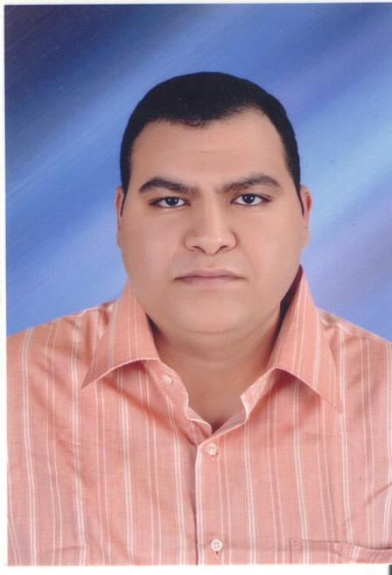

George Abulyamin Sary Daoud

Department of Electrical Engineering Faculty of Engineering, Assiut University , Assiut 71516 , EGYPT

E - mail : goergedaoud@gmail.com

Tel. Office: 031761-031762 Tel. Home:(002-088) 2314194
Mob: 01005033784

Name : George Abulyamin Sary Daoud

Position : Demonstrator. Departments of Electrical Engineering Faculty of Engineering, Assiut University

Date of Birth : 19-3-1983
Place of Birth : France.
Sex : male.
Marital Status : Unmarried
Nationality : Egyptian.

Mailing address : Departments of Electrical Engineering Faculty of Engineering,
Assiut University , Assiut 71516 , EGYPT.

Academic Background :
B.Sc. in Electrical Engineering Faculty of Engineering, Assiut University –Egypt (2004).

Professional Experiences (Occupation) :

Demonstrator: Departments of Electrical Engineering Faculty of Engineering,
Assiut University. (2004)

Scientific Activities :

List of Publications

By
George Abulyamin Sary Daoud

Department of Electrical Engineering Faculty of Engineering, Assiut University , Assiut 71516 , EGYPT
E - mail : goergedaoud@gmail.com

1-

